**Appendix**

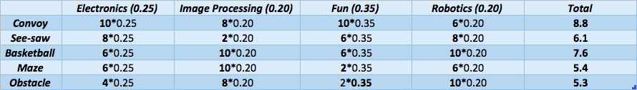

Table A.1: Comparison Table for Projects

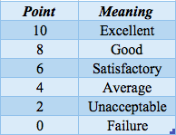

Table A.2: Points and their meanings for Table A.1